INDIAN SCHOOL AL WADI AL KABIR
DEPARTMENT OF SOCIAL SCIENCE
PRE-MID TERM ASSESSMENT- 2023-24
CLASS: VI Max: Marks: 30
Date: 25/05/2023 Time: 1 Hour
General Instructions: -
1. Ensure that you have written your name and roll number correctly.
2. This Question paper has two parts, Section A (History)B (Geography).
3. All questions are compulsory.
4. All the answers must be correctly numbered as in the question paper in the Answer sheet
provided

 | SECTION – A (HISTORY) 15 Marks
I | Multiple Choice Questions: - | 2 Marks
1 | The word ‘India’ is derived from the word___________ which is called Sindhu in Sanskrit.  a) Bharat b) Indus c) Hindos d) Indos | 1 Mark
2 | The language used by the ordinary people for conversation was ________________  a)Hindi b) English c) Prakrit d) All of these. | 1 Mark
II | Fill in the blanks: - | 2 Marks
3 | The process of digging the earth to find out the old objects are called___________. | 1 Mark
4 | ____________are the smaller rivers which merge into a bigger river. | 1 Mark
III | Match the following: - | 2 Marks
 | Column A Column B  - Narmada Valley a. Cities about 2500 years ago  - Magadha b. Hunting and gathering  c. The First big kingdom | 2 Marks
IV | Answer in one or two sentence:- | 2 Marks
7 | Why do you think ordinary men and women did not generally keep records of what they did? | 1 Mark
8 | Who are ‘Archaeologists’? | 1 Mark
V | Answer in brief:- | 4 Marks
9 | List one major difference between manuscripts and inscriptions. | 2 Marks
10 | Observe the picture and answer the questions below: -  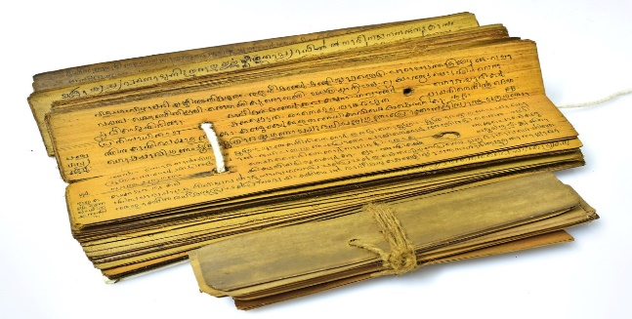  a. Identify and name the given picture  b. Which language is used for writing? | 2 Marks
VI | Answer the following: - | 3 Marks
11 | What were the subjects on which books were written in the past? Which of these would you like to read? | 3 Marks
 | SECTION – B (Geography) 15 Marks
VII | Multiple Choice Questions: - | 2 Marks
1 | The persons who study about the celestial bodies are known as _______.  a. Astronomers b. Geologists c. Explorers d. Scientists | 1 Mark
2 | The biggest planet in the Solar System.  a Saturn b. Jupiter c. Uranus d. Earth | 1 Mark
VIII | Fill in the blanks: - | 2 Marks
3 | A group of _______forming various patterns is called a____________. | 1 Mark
4 | Planets do not have their own ____ and _______ | 1 Mark
IX | Match the following: - | 2 Marks
 | Column A Column B  - New Moon night. a. Universe  - Galaxies b. Poornima  c. Amavasya | 2 Marks
X | Answer in one or two sentence:- | 2 Marks
7 | What is Pole Star? | 1 Mark
8 | What is “Geoid”? | 1 Mark
XI | Answer in brief:- | 4 Marks
9 | Why Earth is called as a unique planet? | 2 Marks
10 | What is meant by the ‘Solar System’? | 2 Marks
XII | Draw a neat and well labelled diagram of the ‘Solar System’. | 3 Marks

